Lawson, John Howard (1894-1977)

John Howard Lawson was born in New York City on 25 September 1894. His first major play, Roger Bloomer (1923), advanced expressionism in the United States, trading the pessimism that frequently defined the form for optimism. Processional (1925), produced by the Theatre Guild, was also formally adventurous. Combining jazz, vaudeville, and dada, and focusing on a labor dispute, it is Lawson’s masterwork.

Nirvana (1926), Loudspeaker (1927), and The International (1928) followed. The latter two were produced by the New Playwrights’ Theatre, a group Lawson co-founded that sought a working-class audience. Loudspeaker, drawing on constructivism, lampoons American politics and big business; The International imagines a future war through juxtaposition of realism, dance, and choral odes. The New Playwrights’ folded in 1929.

Lawson spent most of the early 1930s in Hollywood. He briefly revisited the theatre with Success Story (1932), his first foray into realism and produced by the Group Theatre. In 1933 he became involved in the Screen Writers’ Guild, eventually serving as president. In 1934, he had concurrent New York productions with The Pure in Heart and Gentlewoman. The former draws on the avant-garde; the latter relies on realism.

After joining the Communist Party, Lawson spent the latter years of the 1930s immersed in various left-wing causes and writing The Theory and Technique of Playwriting (1936). His theatrical career concluded with Marching Song (1937), a social realist rendering of an automotive plant strike.

Returning to Hollywood, Lawson spent the next decade writing screenplays and holding leadership positions in the Communist Party. In 1947 he was one of the Hollywood Ten, a group comprised of individuals from the film industry who were purported Communists or sympathetic to revolutionary causes. Lawson testified before House Un-American Activities Committee (HUAC). Cited for contempt, he spent two years in federal prison. His principal writings that followed were Marxist critical studies of United States culture. He died in San Francisco on 11 August 1977.

List of Works

Lawson, John Howard. (1923) Roger Bloomer, New York: Thomas Seltzer.
------ (1925) Processional, New York: Thomas Seltzer.
------ (1927) Loud Speaker, New York: Macaulay.
------ (1927) The International, New York: Macaulay.
------ (1932) Success Story, New York: Farrar and Rinehart.
------ (1934) With a Reckless Preface: Two Plays “The Pure of Heart” and “Gentlewoman,” New York: Farrar and Rinehart.

------ (1936) Theory and Technique of Playwriting, New York: G.P. Putnam’s.
------ (1937) Marching Song. New York: Dramatists Play Service.

References and Further Reading

Benoit, Richard Peter. (2000) A Hegemonic Analysis of John Howard Lawson and the New Playwrights Theatre, Diss. Kent State University.

Bloch, Beverle Rochelle. (1988) John Howard Lawson’s Processional: Modernism in American Theatre in the Twenties, Diss. University of Denver.

Chambers, Jonathan L. (2006) Messiah of the New Technique: John Howard Lawson, Communism, and American Theatre, 1923-1937, Carbondale: Southern Illinois University Press.

Horne, Gerald. (2006) The Final Victim of the Blacklist: John Howard Lawson, Dean of the Hollywood Ten, Oakland: University of California Press.

Jonathan Chambers, Bowling Green State University

Recommended Illustrations:

[Note: The illustrative material listed below is in order of preference. First choice is the production photograph, but if possible, please also use the video footage of Lawson’s HUAC testimony. If the video footage is not possible, then use the still photograph of Lawson testifying at HUAC as a second illustration. If the video footage is used, then the photograph of Lawson testifying is not necessary.]

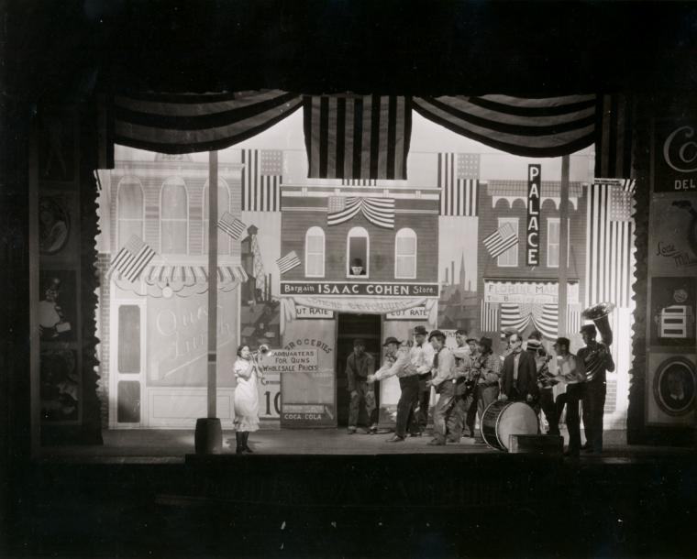

Processional, Garrick Theatre, 1925. Set design by Mordecai Gorelik.
[Source: Billy Rose Theatre Collection, New York Public Library, Image ID: psnypl_the_5354, available at: http://digitalgallery.nypl.org/nypldigital/dgkeysearchdetail.cfm?trg=1&strucID=1888666&imageID=psnypl_the_5354&total=19&num=0&word=processional&s=1&notword=&d=&c=&f=&k=1&lWord=&lField=&sScope=&sLevel=&sLabel=&sort=&imgs=20&pos=2&e=w]

John Howard Lawson testifying before the House Un-American Activities Committee, 1947.
Video Link: http://www.authentichistory.com/1946-1960/4-cwhomefront/1-mccarthyism/John_Howard_Lawson.html

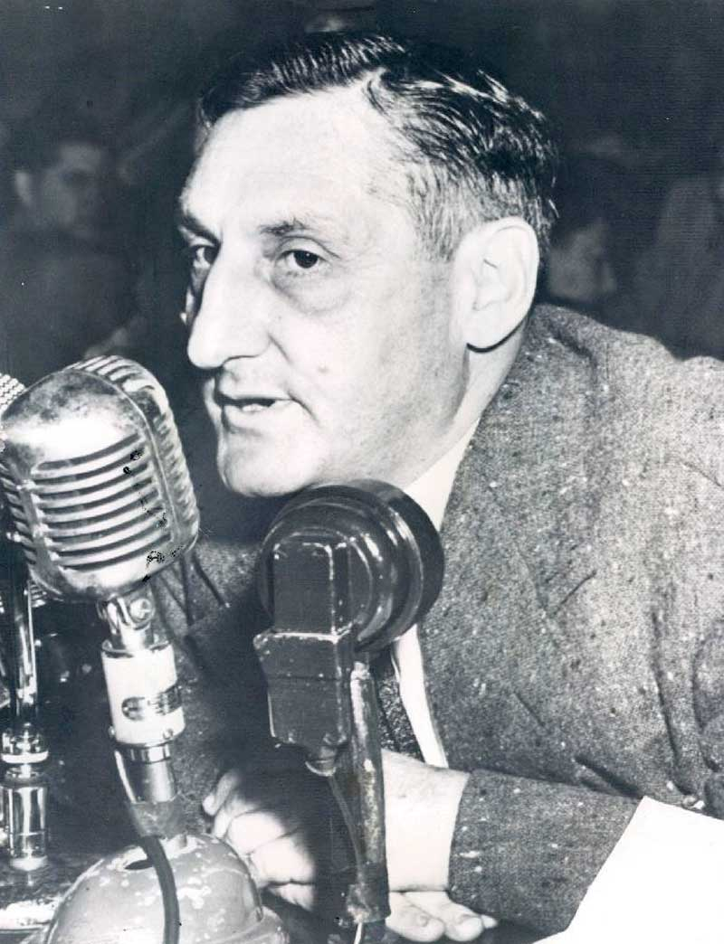

John Howard Lawson testifying before the House Un-American Activities Committee, 1947
[available at: http://skepticism.org/timeline/october-history/9494-house-un-american-activities-committee-holds-writer-john-lawson-contempt.html]

There is a similar photograph that could also be used that is available at: http://www.authentichistory.com/1946-1960/4-cwhomefront/1-mccarthyism/John_Howard_Lawson.html

